NAAN MUDHALVAN

ARTIFICIAL

INTELLIGENCE

**PROJECT TITLE**

**CREATE A CHATBOT IN PYTHON**

**NAME:** RITHANYA P

**REG NO:** 712221104017

**DEPT:** COMPUTER SCIENCE & ENGINEERING

**YEAR & SEM:** 3RD & 5TH

**COLLEGE:** PARK COLLEGE OF ENGINEERING AND

TECHNOLOGY

PHASE 2

INNOVATION

**DESIGN THINKING:**

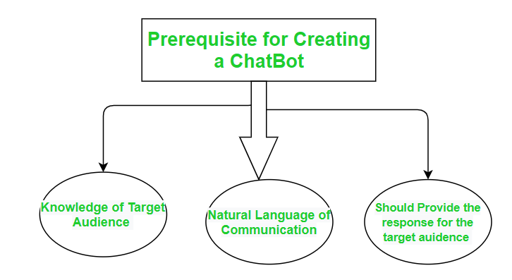

**KNOWLEDGE OF TARGET AUDIENCE:**

* Understanding your target audience is crucial when developing a chatbot in Python. To gather knowledge about your target audience.

**Define Your Audience:**

Identify who your chatbot is intended for. Consider demographics, interests, and needs.

**Conduct Surveys or Research:**

Collect data through surveys, user interviews, or market research to gain insights into your audience's preferences and pain points.

**Create User Personas:**

Develop fictional characters that represent different segments of your audience. This helps in visualizing and understanding their needs.

**Analyze User Data:**

If you have an existing platform or website, analyze user data to learn about user behavior and preferences.

**User Testing:**

Involve real users in the development process to get feedback and adjust the chatbot accordingly.

**Use Analytics Tools:**

Implement analytics tools to track user interactions with your chatbot, allowing you to gather data on user behavior.

* Once you understand your target audience, you can tailor your chatbot's responses, tone, and features to better serve their needs and provide a more personalized experience.

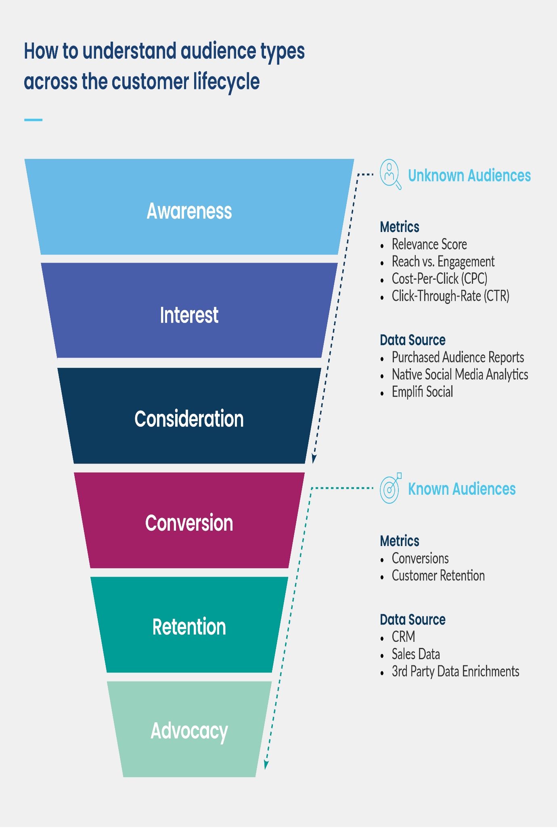

**NATURAL LANGUAGE OF COMMUNICATION:**

In natural language communication with a chatbot, the goal is to make the interaction between the user and the chatbot feel as human-like as possible. This involves using natural language, which means the chatbot should understand and generate responses in a way that is similar to how humans converse. Here are some key aspects of natural language communication in chatbots:

**Natural language processing:**

The chatbot should be able to understand and interpret the user's messages in a way that doesn't require users to use rigid, pre-defined commands.

Natural language understanding (NLU) and natural language processing (NLP) techniques are used to process and comprehend user input.

**Conversational Flow:**

The chatbot should engage in back-and-forth conversations that mimic human dialog. It should understand context and maintain the flow of the conversation.

**Context Awareness:**

A natural language chatbot should remember the context of the conversation, including previous messages and user preferences. It should be able to reference previous messages and responses.

**Sensitivity to Ambiguity:**

Natural language is often ambiguous, and users may not provide explicit or complete information. Chatbots should be able to handle ambiguous queries and ask clarifying questions when necessary.

**Deliver Responses:**

Send the chatbot's response back to the user in a natural and human-readable format.

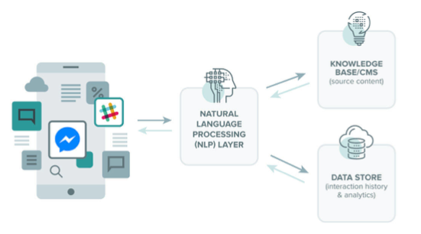

**SHOULD PROVIDE THE RESPONSE FOR THE TARGET AUDIENCE:**

Absolutely, providing responses that are tailored to the specific target audience is a crucial aspect of creating an effective and user-centered chatbot. To do this, you should consider the following:

**Audience Understanding:**

Understand the demographics, preferences, and needs of your target audience. You may need to create user personas to represent different segments of your audience.

**Personalization:**

Tailor responses based on the user's profile or behavior. For example, address the user by name, remember their previous interactions, and provide content or recommendations that align with their interests.

**Language and Tone:**

Use language and a tone that resonates with your audience. If your chatbot is targeting a younger demographic, you might use informal language and emojis. For a professional audience, a more formal tone may be appropriate.

**Content Relevance:**

Ensure that the information or responses provided are relevant to the user's context and needs. This might involve offering different responses or content based on the user's history or preferences.

**Localization:**

If your chatbot is used in different regions, consider localization. Provide responses in the user's preferred language and offer content that is culturally appropriate.

